Perennials &

Grasses List



** Click Image For More Information**

**Shade**

**Hosta –**

Patriot

[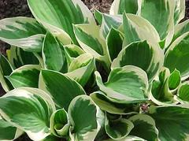](http://www.missouribotanicalgarden.org/PlantFinder/PlantFinderDetails.aspx?taxonid=255958&isprofile=1&basic=patriot)

Blue Angel

[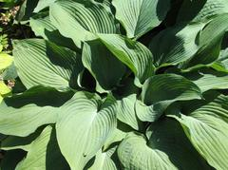](http://www.missouribotanicalgarden.org/PlantFinder/PlantFinderDetails.aspx?taxonid=248612&isprofile=1&basic=blue%20angel%23AllImages)June

[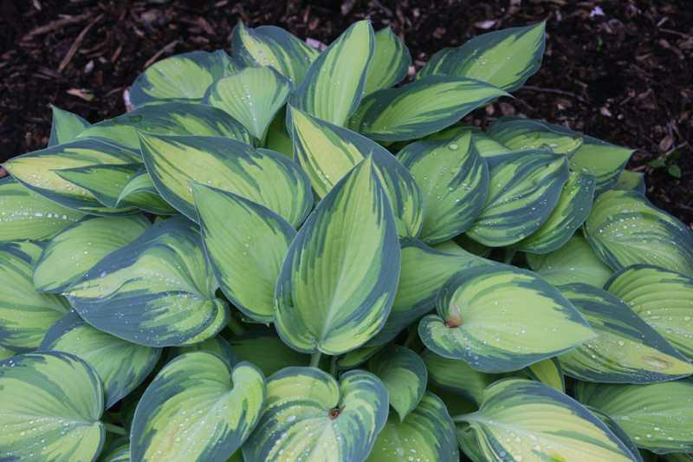](https://www.missouribotanicalgarden.org/PlantFinder/PlantFinderDetails.aspx?kempercode=p490)Stained Glass

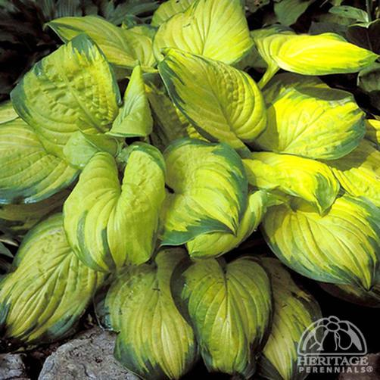

Coast to Coast

[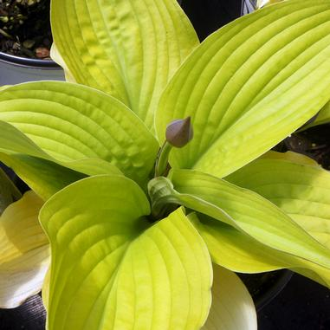](https://www.midwestgroundcovers.com/plant/Hosta-Coast-to-Coast)

**Coral Bells**

Obsidian

[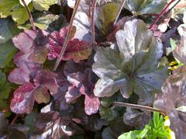](http://www.missouribotanicalgarden.org/PlantFinder/PlantFinderDetails.aspx?taxonid=258936&isprofile=1&basic=obsidian%23AllImages)

Midnight Rose

[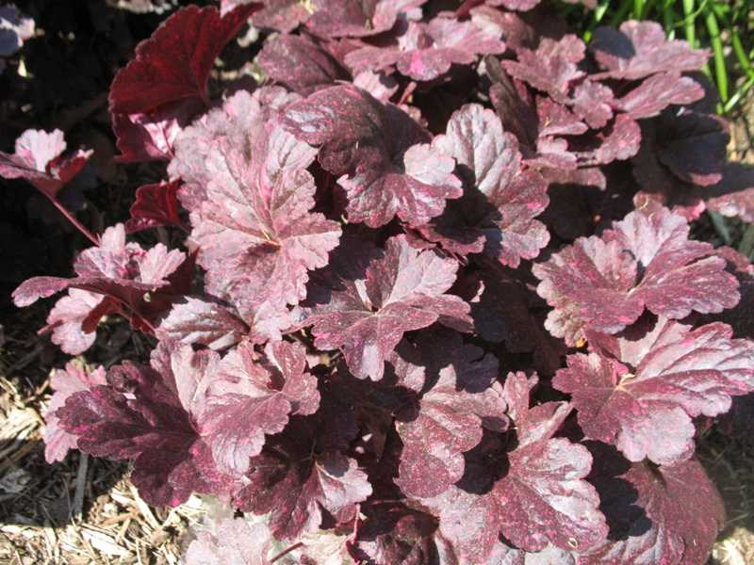](http://www.missouribotanicalgarden.org/PlantFinder/PlantFinderDetails.aspx?taxonid=269546&isprofile=1&basic=midnight%20rose)

Caramel

[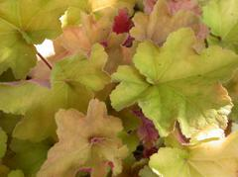](http://www.missouribotanicalgarden.org/PlantFinder/PlantFinderDetails.aspx?taxonid=262099&isprofile=1&basic=caramel)

Citronella

[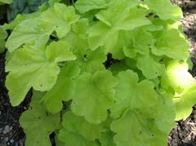](http://www.missouribotanicalgarden.org/PlantFinder/PlantFinderDetails.aspx?taxonid=269216&isprofile=1&basic=citronelle)

Astillbe

[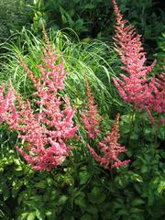](http://www.missouribotanicalgarden.org/PlantFinder/PlantFinderProfileResults.aspx?basic=astilbe)

Japonese Anenome

[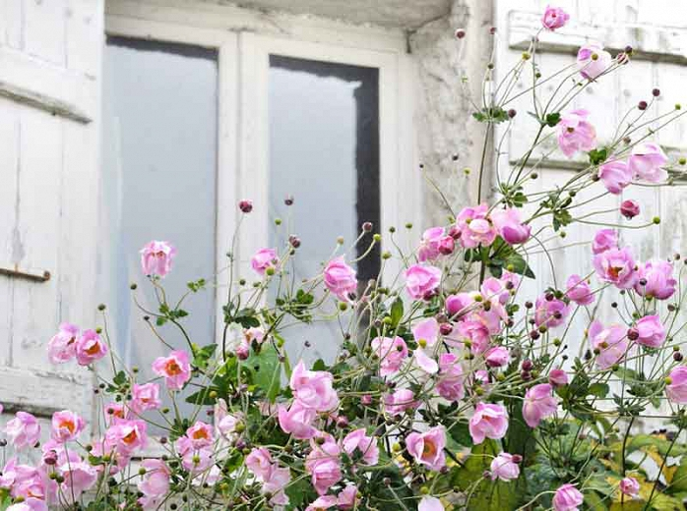](https://www.gardenia.net/plant-variety/japanese-anemones)

Helleborus [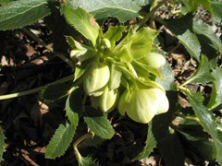](http://www.missouribotanicalgarden.org/PlantFinder/PlantFinderDetails.aspx?taxonid=248767&isprofile=1&basic=helleborus)

Sun King Spikenard

[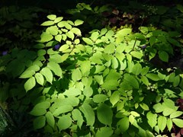](http://www.missouribotanicalgarden.org/PlantFinder/PlantFinderDetails.aspx?taxonid=274056&isprofile=1&basic=Sun%20King)

Japanese Forest Grass

[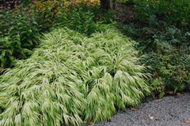](https://www.mortonarb.org/trees-plants/tree-plant-descriptions/japanese-forest-grass)

Jack Frost Brunera

[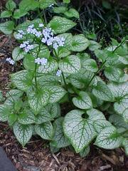](http://www.missouribotanicalgarden.org/PlantFinder/PlantFinderDetails.aspx?taxonid=255997&isprofile=1&basic=Jack%20Frost)

Bleeding Heart

[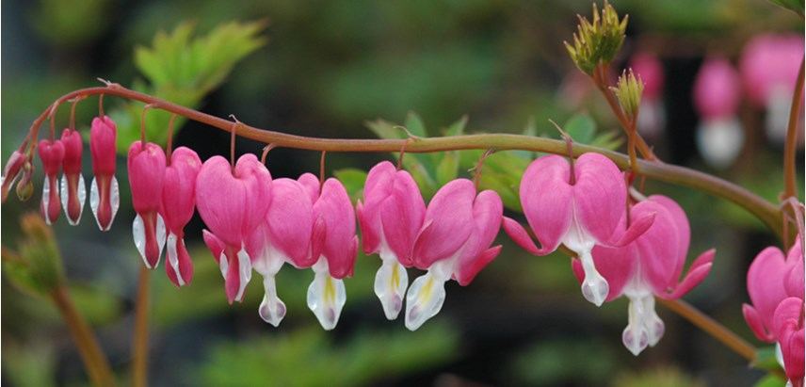](http://www.costafarms.com/plants/bleeding-heart)

**Sun**

Hyssop

[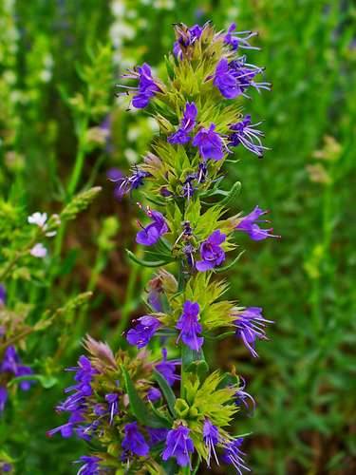](https://www.britannica.com/plant/hyssop)

Allium

[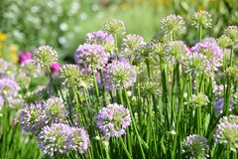](http://www.missouribotanicalgarden.org/PlantFinder/PlantFinderDetails.aspx?taxonid=263431&isprofile=1&basic=allium)Coreopsis [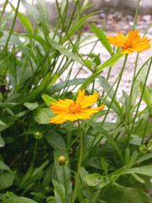](http://www.missouribotanicalgarden.org/PlantFinder/PlantFinderProfileResults.aspx?basic=coreopsis)

Day Lilly

[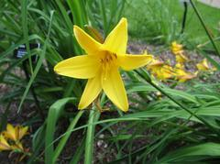](http://www.missouribotanicalgarden.org/PlantFinder/PlantFinderProfileResults.aspx?basic=daylily)

Dianthus [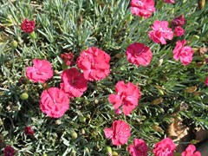](https://www.provenwinners.com/plants/dianthus)Cone Flower

[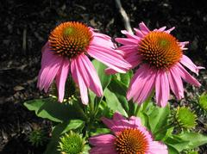](http://www.missouribotanicalgarden.org/PlantFinder/PlantFinderProfileResults.aspx?basic=coneflower)

Geranium Max Frei

[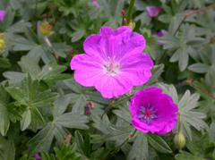](http://www.missouribotanicalgarden.org/PlantFinder/PlantFinderDetails.aspx?taxonid=245835&isprofile=1&basic=max%20frei)

Hibiscus

[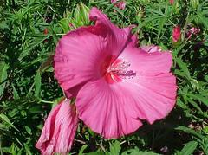](http://www.missouribotanicalgarden.org/PlantFinder/PlantFinderProfileResults.aspx?basic=Hibiscus)

Shasta Daisy [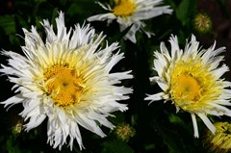](http://www.missouribotanicalgarden.org/PlantFinder/PlantFinderProfileResults.aspx?basic=Shasta%20Daisy)

Liatris

[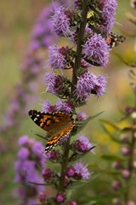](http://www.missouribotanicalgarden.org/PlantFinder/PlantFinderDetails.aspx?taxonid=277341&isprofile=1&basic=liatris)

Nepeta

[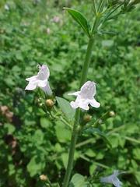](http://www.missouribotanicalgarden.org/PlantFinder/PlantFinderDetails.aspx?taxonid=281538&isprofile=1&basic=Nepeta)

Phlox [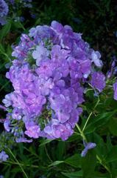](http://www.missouribotanicalgarden.org/PlantFinder/PlantFinderDetails.aspx?taxonid=261291&isprofile=1&basic=Phlox)

Blackeyed Eyed Suzan

[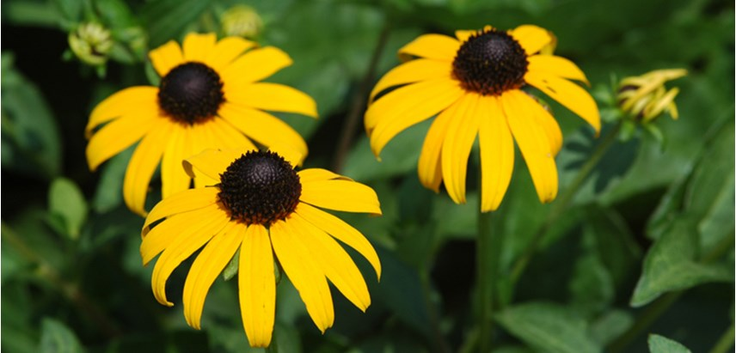](http://www.costafarms.com/plants/black-eyed-susan)Salvia

[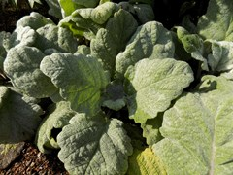](http://www.missouribotanicalgarden.org/PlantFinder/PlantFinderDetails.aspx?taxonid=281419&isprofile=1&basic=salvia)

Sedum

[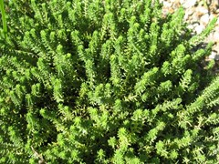](http://www.missouribotanicalgarden.org/PlantFinder/PlantFinderProfileResults.aspx?basic=sedum)