Mckinley Garden Center Plant List

(Sun)



Click picture for further information

3’ and under -

Spilled Wine Weigela Pugster Butterfly Bush

[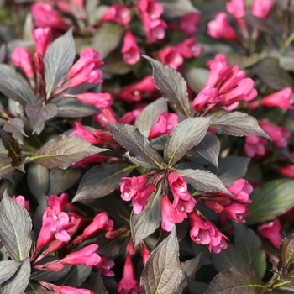](https://www.monrovia.com/plant-catalog/plants/3111/spilled-wine-weigela/)

Magic Carpet Spirea

[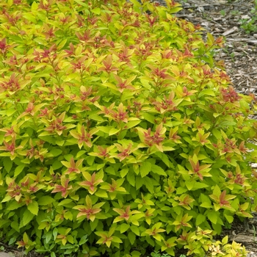](https://www.missouribotanicalgarden.org/PlantFinder/PlantFinderDetails.aspx?taxonid=270499&isprofile=1&basic=magic%20carpet)

Candy Corn Spirea

[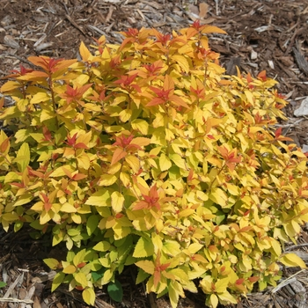](https://www.missouribotanicalgarden.org/PlantFinder/PlantFinderDetails.aspx?taxonid=270965&isprofile=1&basic=double%20play)

Drift Roses

[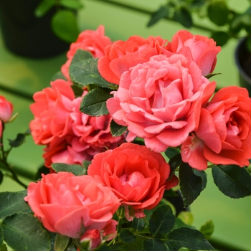](https://www.driftroses.com/collection)

[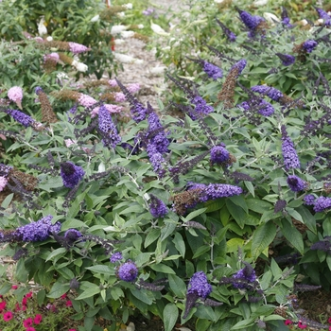](https://www.provenwinners.com/plants/buddleia/pugster-blue-butterfly-bush-buddleia-x)

Yuki Cherry Blossom Deutzia

[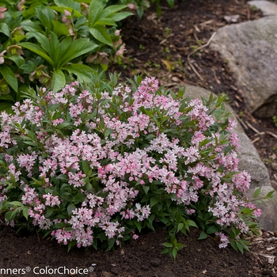](https://www.missouribotanicalgarden.org/PlantFinder/PlantFinderDetails.aspx?taxonid=299467&isprofile=1&basic=yuki%20cherry%20blossom)

Yuki Snowflake Deutzia

[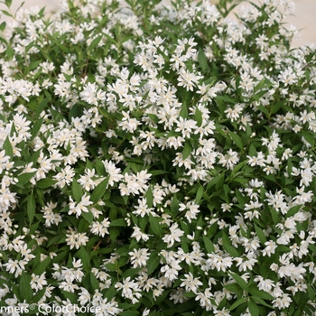](https://www.provenwinners.com/plants/deutzia/yuki-snowflake-deutzia-x)

Bobo Hydrangea

[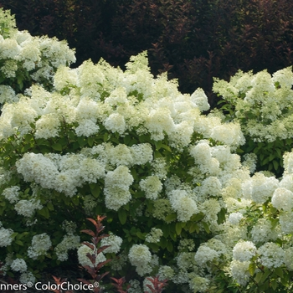](https://www.missouribotanicalgarden.org/PlantFinder/PlantFinderDetails.aspx?taxonid=274259&isprofile=1&basic=Bobo)

Big Bang Spirea

[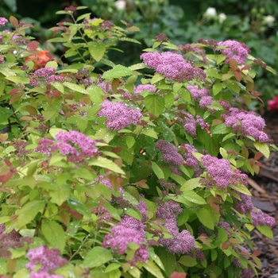](https://www.provenwinners.com/plants/spiraea/double-play-big-bang-spirea-spiraea-x)

Bowling Ball Arbovitae

[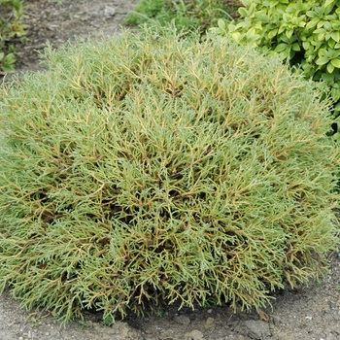](https://www.missouribotanicalgarden.org/PlantFinder/PlantFinderDetails.aspx?taxonid=274501&isprofile=1&basic=Bowling%20ball)

Blue Star Juniper

[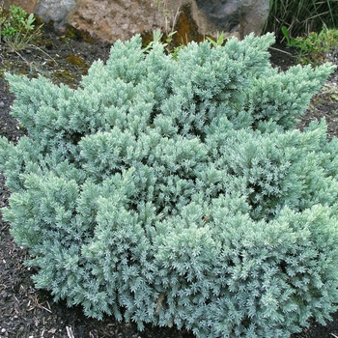](https://www.missouribotanicalgarden.org/PlantFinder/PlantFinderDetails.aspx?taxonid=249904&isprofile=1&adv=Blue%20star)

Green Velvet Boxwood

](https://www.missouribotanicalgarden.org/PlantFinder/PlantFinderDetails.aspx?taxonid=243327&isprofile=1&basic=green%20velvet)

Show Off Sugar Baby Forsythia

[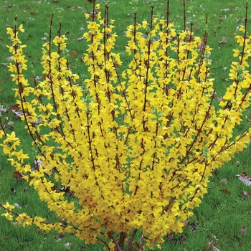](https://www.missouribotanicalgarden.org/PlantFinder/PlantFinderDetails.aspx?taxonid=267867&isprofile=1&basic=show%20off)

Fothergilla Gardenii

[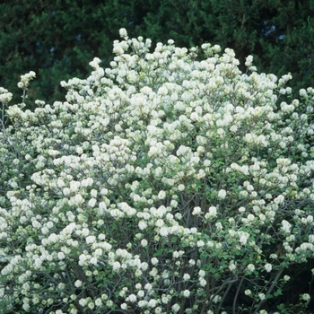](https://www.missouribotanicalgarden.org/PlantFinder/PlantFinderDetails.aspx?taxonid=281020&isprofile=1&basic=Fothergilla)

Oso Roses

[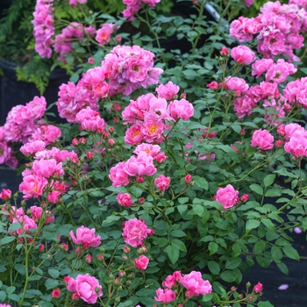](https://www.provenwinners.com/plants/rosa/oso-easy-paprika-rose-rosa-sp)

Motherlode Juniper

[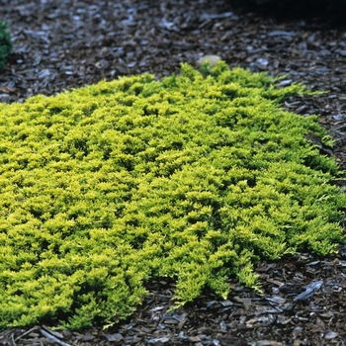](https://www.missouribotanicalgarden.org/PlantFinder/PlantFinderDetails.aspx?taxonid=249874&isprofile=1&basic=Juniperus%20horizontalis)

3’-6’

Chardonnay Pearls Deutzia

[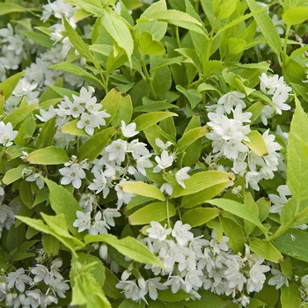](https://www.missouribotanicalgarden.org/PlantFinder/PlantFinderDetails.aspx?taxonid=262936&isprofile=1&basic=chardonnay%20pearls)

Hummingbird Clethra

[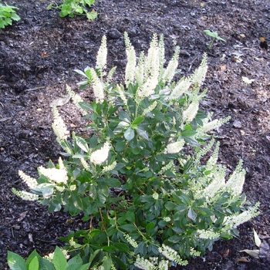](https://www.missouribotanicalgarden.org/PlantFinder/PlantFinderDetails.aspx?taxonid=244373&isprofile=1&basic=Clethra%20alnifolia)

Little Lime Hydrangea

[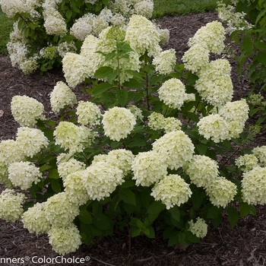](https://www.missouribotanicalgarden.org/PlantFinder/PlantFinderDetails.aspx?taxonid=273280&isprofile=1&basic=little%20lime)

Little Quick Fire Hydrangea

[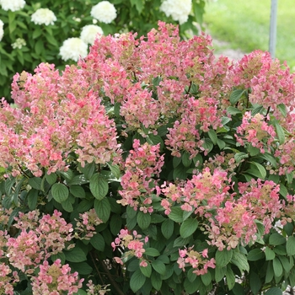](https://www.missouribotanicalgarden.org/PlantFinder/PlantFinderDetails.aspx?taxonid=299412&isprofile=1&basic=little%20quick%20fire)

Little Devil Ninebark

[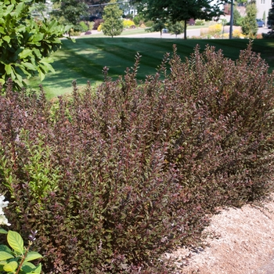](https://www.gardeners.com/buy/little-devil-ninebark/8587174.html)

Tiny Wine Ninebark

[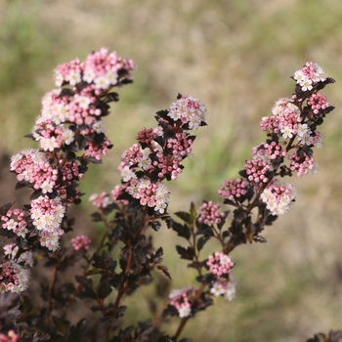](https://www.missouribotanicalgarden.org/PlantFinder/PlantFinderDetails.aspx?taxonid=359227&isprofile=1&basic=tiny%20wine)

Fine Wine Weigela

[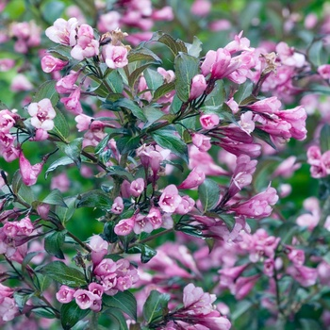](https://www.missouribotanicalgarden.org/PlantFinder/PlantFinderDetails.aspx?taxonid=262953&isprofile=1&basic=fine%20wine)

Strawberry Sundae

Hydrangea

[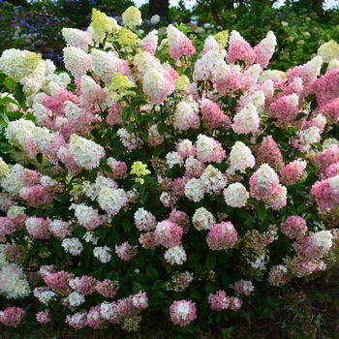](https://www.missouribotanicalgarden.org/PlantFinder/PlantFinderDetails.aspx?taxonid=296289&isprofile=1&basic=strawberry%20sundae)

Mt. Airys Fothergilla

[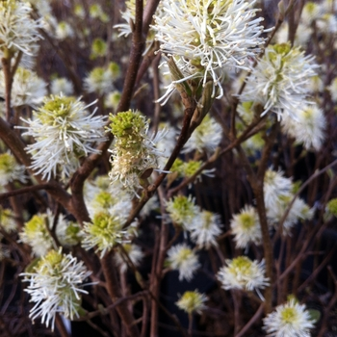](https://www.missouribotanicalgarden.org/PlantFinder/PlantFinderDetails.aspx?taxonid=245775&isprofile=1&basic=fothergilla)

Little Goblin Guy

[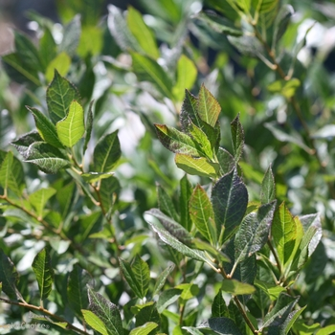](https://www.provenwinners.com/plants/ilex/little-goblin-guy-winterberry-holly-ilex-verticillata)

Little Goblin Red

[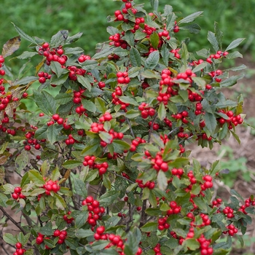](https://www.missouribotanicalgarden.org/PlantFinder/PlantFinderDetails.aspx?taxonid=249162&isprofile=1&basic=winterberry)

Little Goblin Orange

[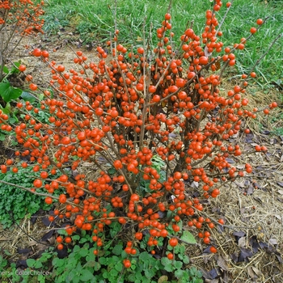](https://www.provenwinners.com/plants/ilex/little-goblin-orange-winterberry-holly-ilex-verticillata)

SummerWine Ninebark

[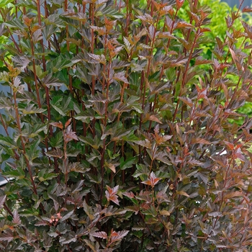](https://www.missouribotanicalgarden.org/PlantFinder/PlantFinderDetails.aspx?taxonid=262084&isprofile=1&basic=summer%20wine)

Wine and Roses Weigela

[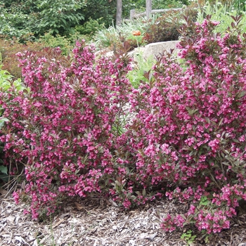](https://www.missouribotanicalgarden.org/PlantFinder/PlantFinderDetails.aspx?taxonid=241521&isprofile=1&basic=wine%20and%20roses)

Green Mountain Boxwood

[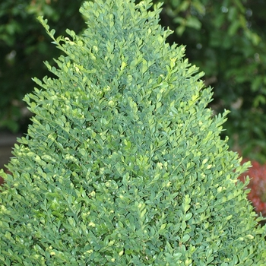](https://www.missouribotanicalgarden.org/PlantFinder/PlantFinderDetails.aspx?taxonid=254202&isprofile=1&basic=green%20mountain)

Wintergreen Boxwood

[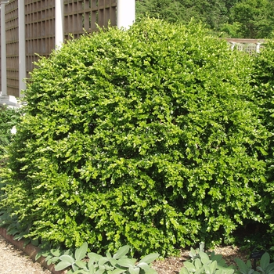](https://www.missouribotanicalgarden.org/PlantFinder/PlantFinderDetails.aspx?taxonid=243331&isprofile=1&basic=korean%20boxwood)

WinterGem Boxwood

[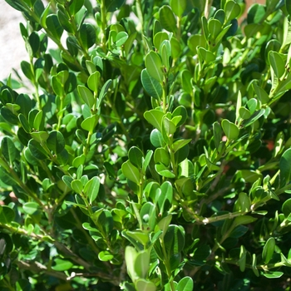](https://www.missouribotanicalgarden.org/PlantFinder/PlantFinderDetails.aspx?taxonid=259285&isprofile=1&basic=boxwood)

Dwarf Korean Lilac

[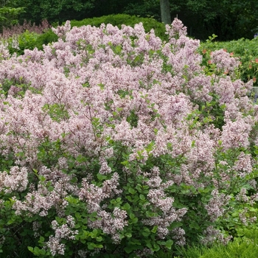](http://www.missouribotanicalgarden.org/PlantFinder/PlantFinderDetails.aspx?taxonid=282999&isprofile=1&basic=Syringa%20meyeri)

Bloomerang Lilac

[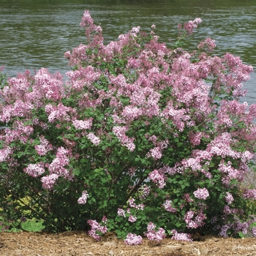](http://www.missouribotanicalgarden.org/PlantFinder/PlantFinderDetails.aspx?taxonid=269258&isprofile=1&basic=bloomerang)

Miss Kim Lilac

[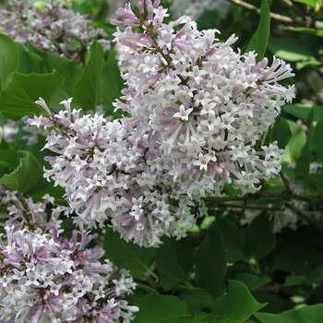](http://www.missouribotanicalgarden.org/PlantFinder/PlantFinderDetails.aspx?taxonid=260601&isprofile=1&basic=miss%20kim)

Knock Out Roses

[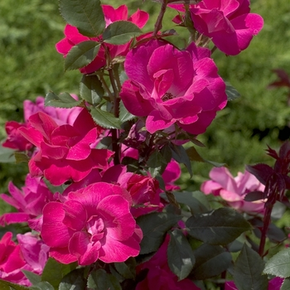](http://www.missouribotanicalgarden.org/PlantFinder/PlantFinderDetails.aspx?taxonid=252230&isprofile=1&basic=knock%20out)

Gold Mop Cypress

[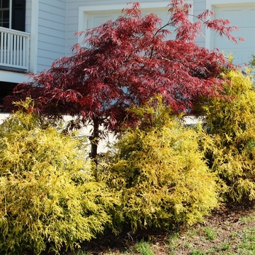](http://www.missouribotanicalgarden.org/PlantFinder/PlantFinderDetails.aspx?taxonid=256551&isprofile=1&basic=Chamaecyparis%20pisifera)

Gold Lace Juniper

[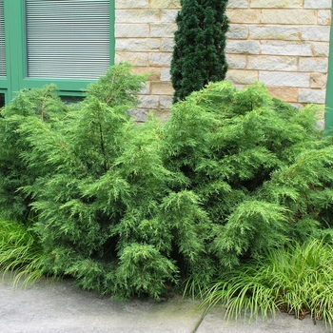](https://www.monrovia.com/plant-catalog/plants/230/gold-lace-juniper/)

Densiformis Yew

[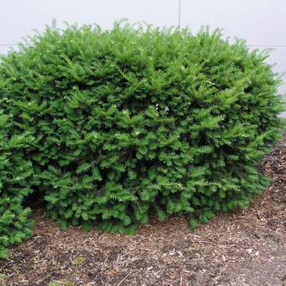](http://www.missouribotanicalgarden.org/PlantFinder/PlantFinderDetails.aspx?taxonid=253956&isprofile=1&basic=densiformis)

Sea Green Juniper

[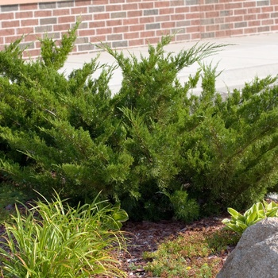](http://www.missouribotanicalgarden.org/PlantFinder/PlantFinderDetails.aspx?taxonid=261524&isprofile=1&basic=sea%20green)

Miracle on the Hudson Rose

](https://www.handpickedplants.com/plants/miracle-on-the-hudson-rose/)

Pinky Winky Hydrangea

[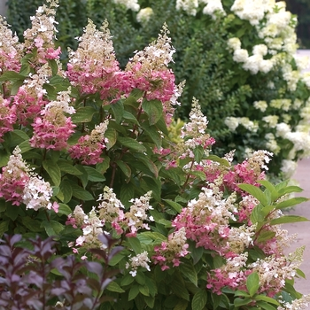](http://www.missouribotanicalgarden.org/PlantFinder/PlantFinderDetails.aspx?taxonid=266898&isprofile=1&basic=panicle%20hydrangea)

6’ Plus

Diablo Ninebark

[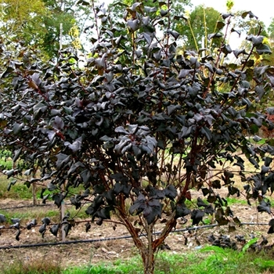](http://www.missouribotanicalgarden.org/PlantFinder/PlantFinderDetails.aspx?taxonid=255943&isprofile=1&basic=ninebark%23AllImages)

Amber Jubilee Ninebark

[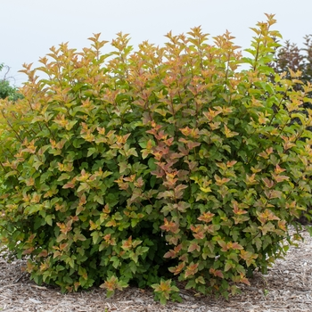](http://www.missouribotanicalgarden.org/PlantFinder/PlantFinderDetails.aspx?taxonid=293651&isprofile=1&basic=amber%20jubilee)

Burning Bush

[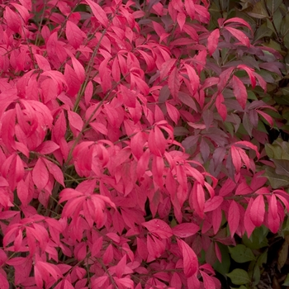](http://www.missouribotanicalgarden.org/PlantFinder/PlantFinderDetails.aspx?taxonid=263216&isprofile=1&basic=burning%20bush)

Limelight Hydrangea

[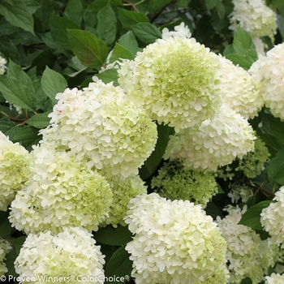](http://www.missouribotanicalgarden.org/PlantFinder/PlantFinderDetails.aspx?taxonid=259054&isprofile=1&basic=Hydrangea%20paniculata)

Quick Fire Hydrangea

[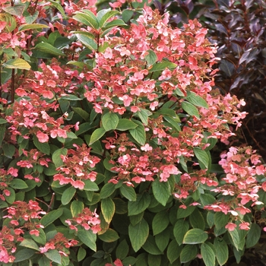](https://www.provenwinners.com/plants/hydrangea/quick-fire-panicle-hydrangea-hydrangea-paniculata)

Vanilla Strawberry Hydrangea

[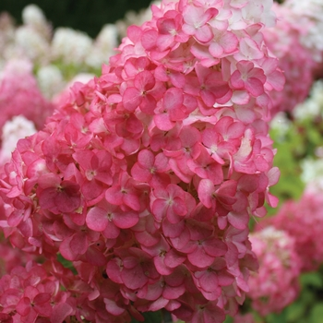](http://www.missouribotanicalgarden.org/PlantFinder/PlantFinderDetails.aspx?taxonid=293649&isprofile=1&basic=vanilla%20strawberry)

Rose Of Sharon

[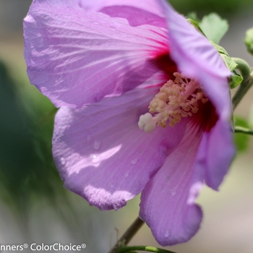](http://www.missouribotanicalgarden.org/PlantFinder/PlantFinderDetails.aspx?taxonid=282593&isprofile=1&basic=rose%20of%20sharon)

Fine Line Buckthorn

[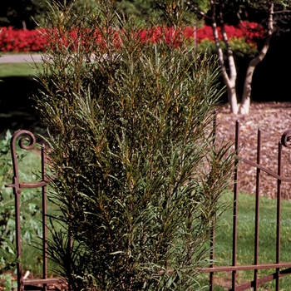](http://www.missouribotanicalgarden.org/PlantFinder/PlantFinderDetails.aspx?taxonid=262918&isprofile=1&basic=buckthorn)

Standing Ovation

Serviceberry

[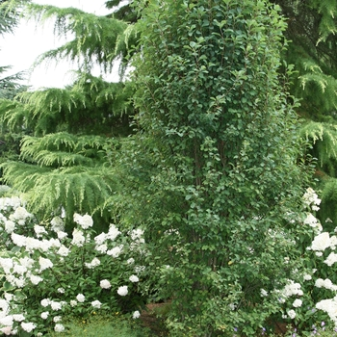](https://www.springhillnursery.com/product/standing-ovation-serviceberry)