Mckinley Garden Center Plant List

(Shade to Part Sun)



Click picture for further information

3’ and Under-

My Monet Weigela

[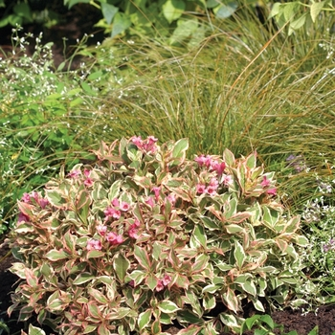](http://www.missouribotanicalgarden.org/PlantFinder/PlantFinderDetails.aspx?taxonid=264645&isprofile=1&basic=My%20Monet)

Crème Fraiche Deutzia

[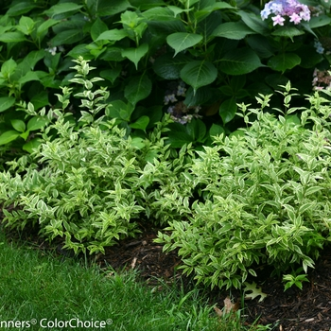](https://www.provenwinners.com/plants/deutzia/creme-fraiche-deutzia-gracilis)

Yuki Cherry Blossom

Deutzia

[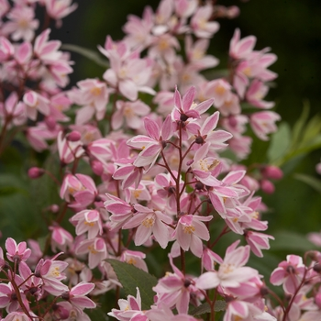](http://www.missouribotanicalgarden.org/PlantFinder/PlantFinderDetails.aspx?taxonid=299467&isprofile=1&basic=yuki%20cherry%20blossom)

Yuki Snowflake Deutzia

[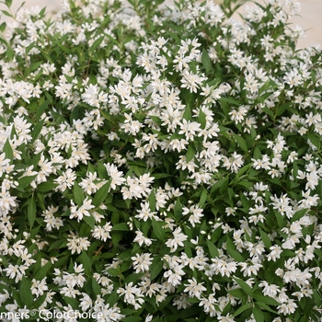](https://www.provenwinners.com/plants/deutzia/yuki-snowflake-deutzia-x)

Wee White Invincebelle

Hydrangea

[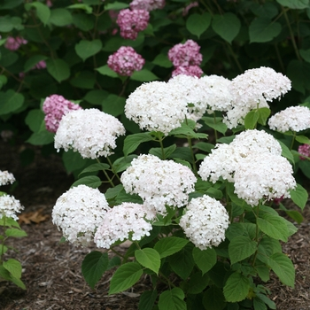](http://www.missouribotanicalgarden.org/PlantFinder/PlantFinderDetails.aspx?taxonid=441377&isprofile=1&basic=wee%20white)

Tiny Tuff Stuff Hydrangea

[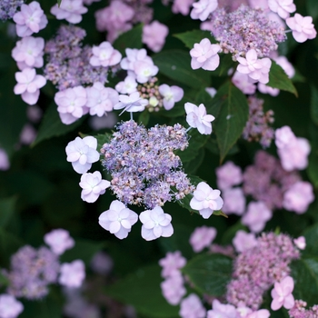](https://www.provenwinners.com/plants/hydrangea/tiny-tuff-stuff-mountain-hydrangea-hydrangea-serrata)

Tuff Stuff Hydrangea

[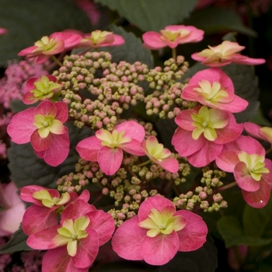](https://www.provenwinners.com/plants/hydrangea/tuff-stuff-reblooming-mountain-hydrangea-hydrangea-serrata)

Fothergilla Gardenii

[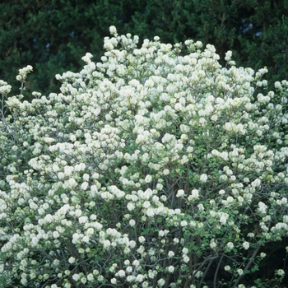](https://www.missouribotanicalgarden.org/PlantFinder/PlantFinderDetails.aspx?taxonid=281020&isprofile=1&basic=Fothergilla)

Show Off Sugar Baby

Forsythia

[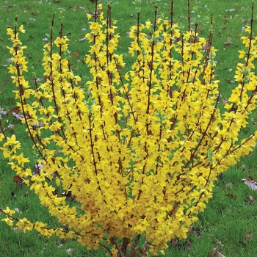](https://www.missouribotanicalgarden.org/PlantFinder/PlantFinderDetails.aspx?taxonid=267867&isprofile=1&basic=show%20off)

Green Velvet Boxwood

](https://www.missouribotanicalgarden.org/PlantFinder/PlantFinderDetails.aspx?taxonid=243327&isprofile=1&basic=green%20velvet)

Green Gem Boxwood

[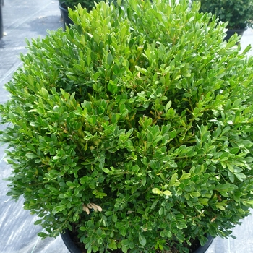](http://www.missouribotanicalgarden.org/PlantFinder/PlantFinderDetails.aspx?taxonid=243326&isprofile=1&basic=green%20gem)

Everlow Yew

[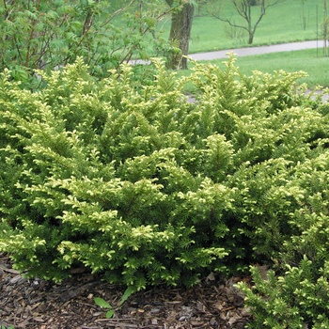](http://www.missouribotanicalgarden.org/PlantFinder/PlantFinderDetails.aspx?kempercode=q360)

Gem Box Holly

[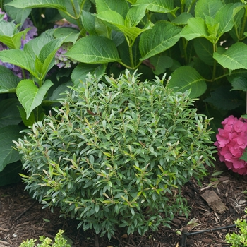](https://www.provenwinners.com/plants/ilex/gem-box-inkberry-holly-ilex-glabra)

Little Henry Garnet Itea

[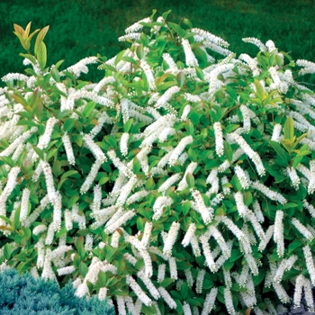](http://www.missouribotanicalgarden.org/PlantFinder/PlantFinderDetails.aspx?taxonid=249813&isprofile=1&basic=little%20henry)

Summer Crush Hydrangea

[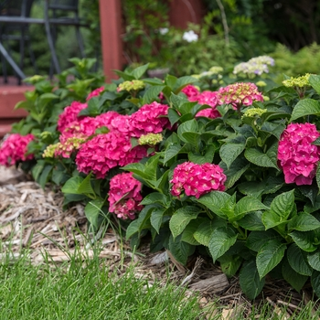](http://www.endlesssummerblooms.com/the-collection/summer-crush)

Sikes Dwarf Oak Leaf

Hydrangea

[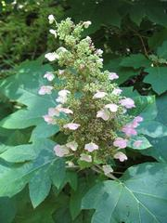](http://www.missouribotanicalgarden.org/PlantFinder/PlantFinderDetails.aspx?taxonid=258877&isprofile=0&)

3-6’-

Chardonnay Pearls Deutzia

[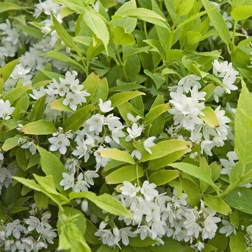](http://www.missouribotanicalgarden.org/PlantFinder/PlantFinderDetails.aspx?taxonid=262936&isprofile=1&basic=chardonnay%20pearls)

Henry’s Garnet Itea

[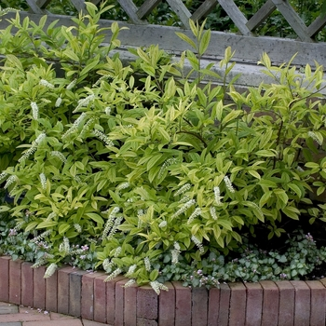](http://www.missouribotanicalgarden.org/PlantFinder/PlantFinderDetails.aspx?taxonid=249812&isprofile=1&basic=henry's%20garnet)

Mt. Airy’s Fother Gilla

[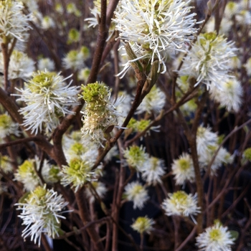](https://www.missouribotanicalgarden.org/PlantFinder/PlantFinderDetails.aspx?taxonid=245775&isprofile=1&basic=fothergilla)

Annabelle Hydrangea[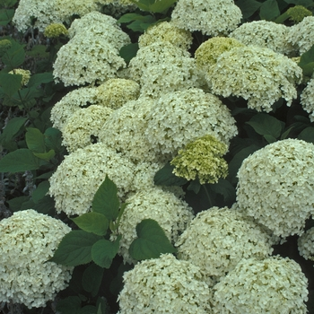](https://www.monrovia.com/plant-catalog/plants/1445/annabelle-hydrangea/)

Bloomstruck Hydrangea

[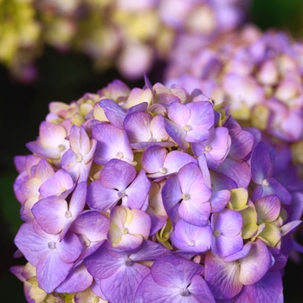](http://www.missouribotanicalgarden.org/PlantFinder/PlantFinderDetails.aspx?taxonid=301064&isprofile=1&basic=bloomstruck)

Ruby Slippers Oak Leaf Hydrangea

[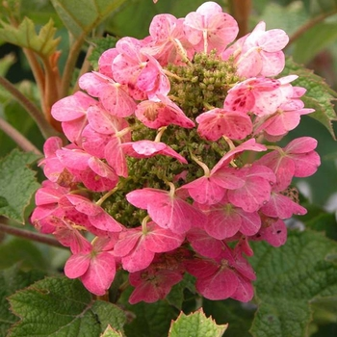](http://www.missouribotanicalgarden.org/PlantFinder/PlantFinderDetails.aspx?taxonid=274435&isprofile=1&basic=ruby%20slipper)

Hummingbird Clethra

[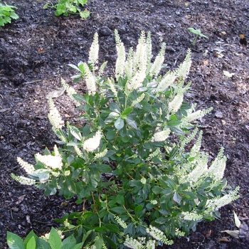](http://www.missouribotanicalgarden.org/PlantFinder/PlantFinderDetails.aspx?taxonid=244373)

Ruby Spice Clethra

[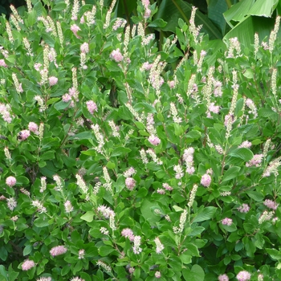](http://www.missouribotanicalgarden.org/PlantFinder/PlantFinderDetails.aspx?taxonid=260880&isprofile=1&basic=ruby%20spice)

Ivory Halo Redtwig Dogwood

[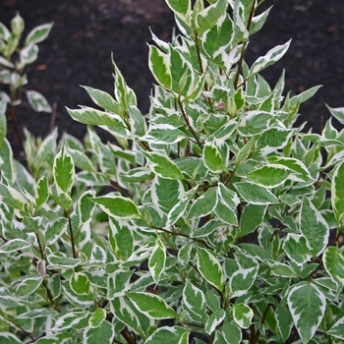](http://www.missouribotanicalgarden.org/PlantFinder/PlantFinderDetails.aspx?taxonid=243963&isprofile=1&basic=ivory%20halo)

Arctic Fire Redtwig Dogwood

[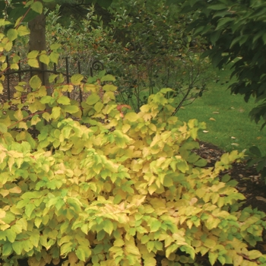](http://www.missouribotanicalgarden.org/PlantFinder/PlantFinderDetails.aspx?taxonid=262959&isprofile=1&basic=arctic%20fire)

Green Mountain Boxwood

[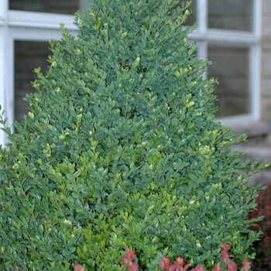](https://www.missouribotanicalgarden.org/PlantFinder/PlantFinderDetails.aspx?taxonid=254202&isprofile=1&basic=green%20mountain)

Wintergreen Boxwood

[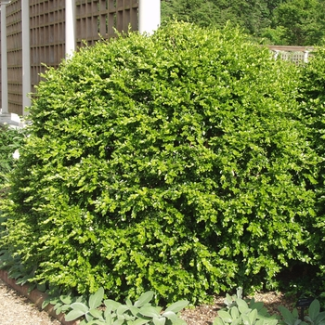](https://www.missouribotanicalgarden.org/PlantFinder/PlantFinderDetails.aspx?taxonid=243331&isprofile=1&basic=korean%20boxwood)

Wintergem Boxwood

[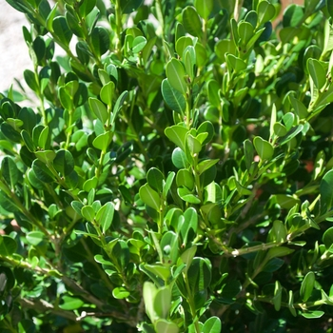](https://www.missouribotanicalgarden.org/PlantFinder/PlantFinderDetails.aspx?taxonid=259285&isprofile=1&basic=boxwood)

Spice Baby Viburnum

[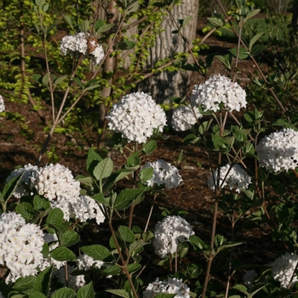](http://www.missouribotanicalgarden.org/PlantFinder/PlantFinderDetails.aspx?taxonid=364359&isprofile=1&basic=spice%20baby)

Brandywine Viburnum

[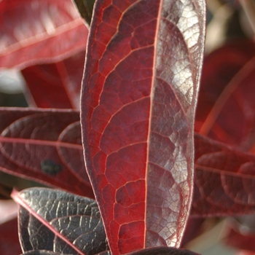](http://www.missouribotanicalgarden.org/PlantFinder/PlantFinderDetails.aspx?taxonid=265905&isprofile=1&basic=brandywine)

Little Goblin Guy

[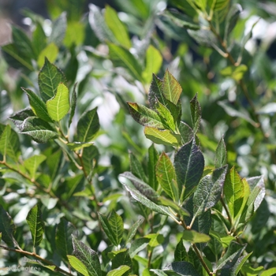](https://www.provenwinners.com/plants/ilex/little-goblin-guy-winterberry-holly-ilex-verticillata)

Little Goblin Red

[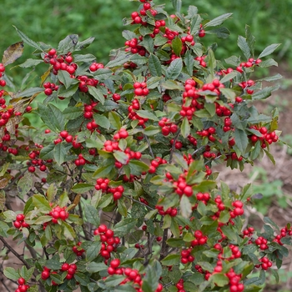](https://www.missouribotanicalgarden.org/PlantFinder/PlantFinderDetails.aspx?taxonid=249162&isprofile=1&basic=winterberry)

Little Goblin orange

[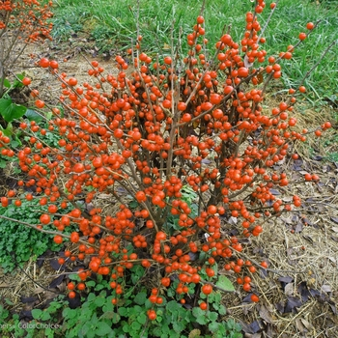](https://www.provenwinners.com/plants/ilex/little-goblin-orange-winterberry-holly-ilex-verticillata)

Honeymooner Holly

[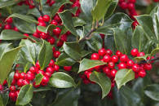](http://www.nashvillenursery.com/plant_details.php?id=281)

Nordic Holly

[](http://www.missouribotanicalgarden.org/PlantFinder/PlantFinderDetails.aspx?taxonid=249145&isprofile=0)

6’ Plus-

Blue Muffin Viburnum

[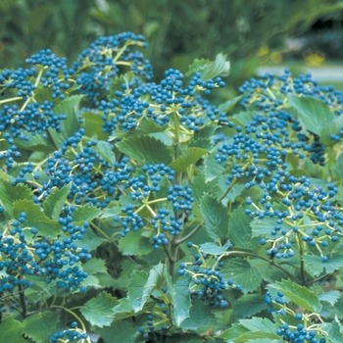](http://www.missouribotanicalgarden.org/PlantFinder/PlantFinderDetails.aspx?taxonid=260678&isprofile=1&basic=blue%20muffin)

Cardinal Candy Viburnum

[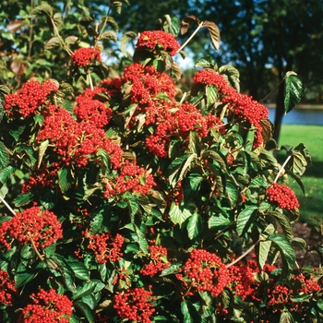](http://www.missouribotanicalgarden.org/PlantFinder/PlantFinderDetails.aspx?taxonid=264439&isprofile=1&basic=cardinal%20candy%5C)

Spice Girl Viburnum

[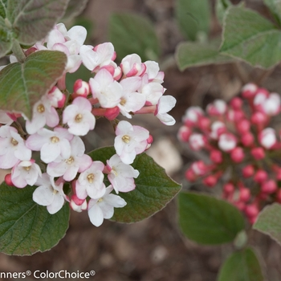](https://www.provenwinners.com/plants/viburnum/spice-girl-korean-spice-viburnum-viburnum-carlesii)

Burkwood Viburnum

[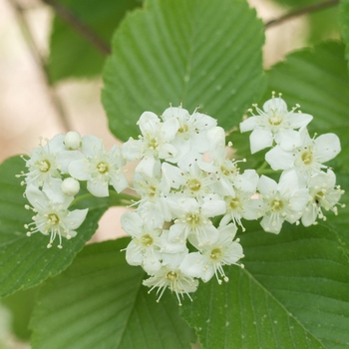](http://www.missouribotanicalgarden.org/PlantFinder/PlantFinderDetails.aspx?taxonid=279019&isprofile=1&basic=burkwood)

Juddi Viburnum

[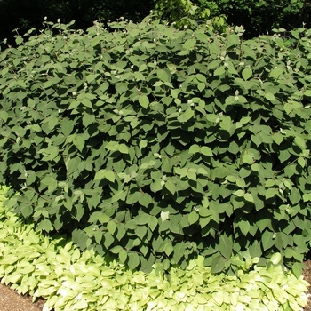](https://www.missouribotanicalgarden.org/PlantFinder/PlantFinderDetails.aspx?taxonid=255729&isprofile=0&)

Mariessi Viburnum

[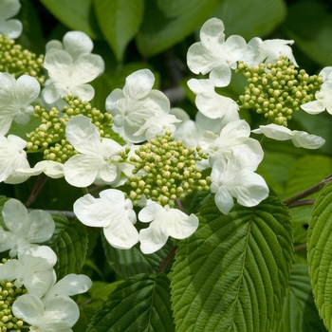](http://www.missouribotanicalgarden.org/PlantFinder/PlantFinderDetails.aspx?kempercode=c358)

Autumn Jazz Viburnum

[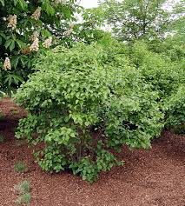](http://www.missouribotanicalgarden.org/PlantFinder/PlantFinderDetails.aspx?taxonid=242639&isprofile=1&basic=autumn%20Jazz)

Arnold’s Promise Witchazel

[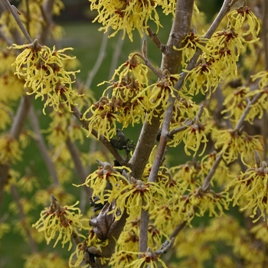](https://www.missouribotanicalgarden.org/PlantFinder/PlantFinderDetails.aspx?taxonid=246177&isprofile=0&)

Diane Witchazel

[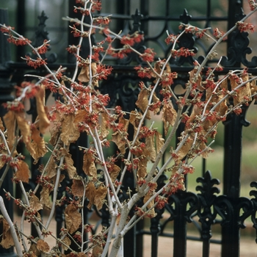](http://www.missouribotanicalgarden.org/PlantFinder/PlantFinderDetails.aspx?taxonid=246178&isprofile=0&)

Fine Line Buckthorn

[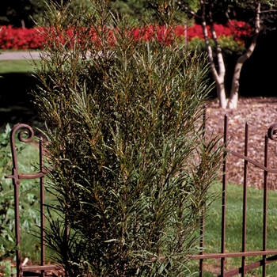](http://www.missouribotanicalgarden.org/PlantFinder/PlantFinderDetails.aspx?taxonid=262918&isprofile=1&basic=buckthorn)

Standing Ovation Serviceberry

[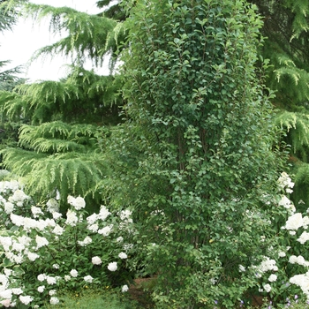](https://www.springhillnursery.com/product/standing-ovation-serviceberry)

Alice Oak Leaf Hydrangea

[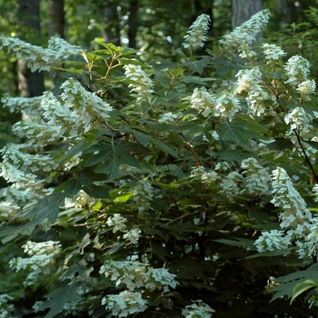](http://www.missouribotanicalgarden.org/PlantFinder/PlantFinderDetails.aspx?taxonid=254311&isprofile=0&)